- Data Design
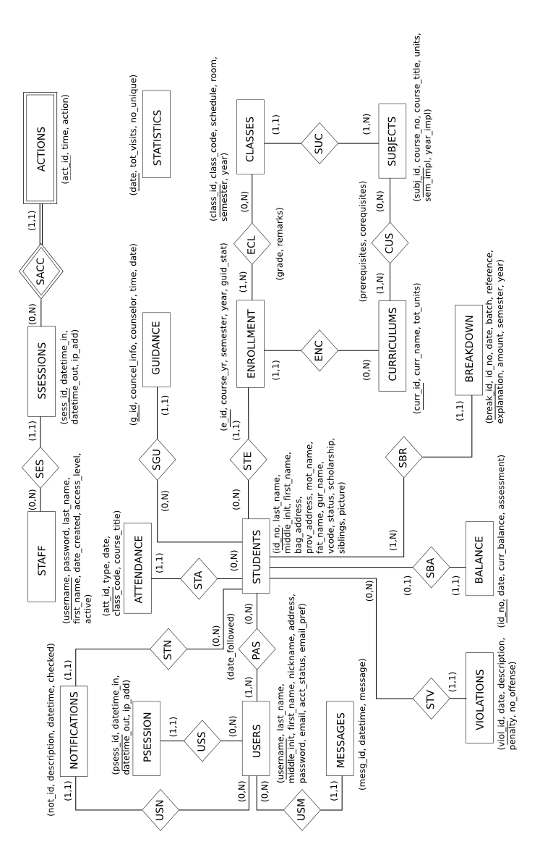
Figure 1 The above figure is the Entity-Relationship Diagram of the OASIS Database.
Relational Database Scheme

USERS(username, last_name, middle_init, first_name, nickname, address, password, email, acct_status, email_pref)

PSESSION(psess_id, datetime_in, datetime_out, ip_add, username)
FK username References USERS Nulls Not Allowed, Delete Restrict, Update Cascade

PAS(username, id_no, date_followed)
FK username References USERS Nulls Not Allowed, Delete Cascade, Update Cascade
FK id_no References STUDENTS nulls not allowed Delete Cascade Update Cascade

STUDENTS(id_no, last_name, middle_init, first_name, bag_address, prov_address, mot_name, fat_name, gur_name, vcode, status, scholarship, siblings, picture)

VIOLATIONS(viol_id, date, description, penalty, no_offense, id_no)
FK id_no References STUDENTS Nulls Not Allowed, Delete Restrict, Update Cascade

ATTENDANCE(att_id, type, date, class_code, course_title, id_no)
FK id_no References STUDENTS Nulls Not Allowed, Delete Restrict, Update Cascade

BREAKDOWN(break_id, id_no, date, batch, reference, explanation, amount, semester, year, id_no)
FK id_no References STUDENTS Nulls Not Allowed, Delete Restrict, Update Cascade

BALANCE(bal_id, date, curr_balance, assessment, id_no)
FK id_no References STUDENTS Nulls Not Allowed, Delete Restrict, Update Cascade

ENROLLMENT(e_id, course_yr, semester, year, guid_stat, id_no, curr_id)
FK id_no References STUDENTS Nulls Not Allowed, Delete Restrict, Update Cascade
FK curr_id References CURRICULUMS Nulls Not Allowede, Delete Restrict, Update Cascade

ECL (e_id, class_id, grade, remarks)
FK e_id References ENROLLMENT Nulls Not Allowed, Delete Restrict, Update Cascade
FK class_id References CLASSES Nulls Not Allowed, Delete Restrict, Update Cascade

CLASSES(class_id, class_code, schedule, room, subj_id, semester, year)
FK subj_id References SUBJECTS Nulls Not Allowed, Delete Restrict, Update Cascade

SUBJECTS(subj_id, course_no, course_title, units, sem_impl, year_impl)

CUS (currid, subj_id, prerequisites, corequistes)
FK curr_id References CURRICULUM Nulls Not Allowed, Delete Restrict, Update Cascade
FK subj_id References SUBJECTS Nulls Not Allowed, Delete Restrict, Update Cascade

CURRICULUMS(curr_id, curr_name, tot_units)

STAFF(username, password, last_name, first_name, datecreated, access_level, active)

SSESSIONS(sess_id, datetime_in, datetime_out, username, ip_add)
FK username References STAFF Nulls Not Allowed, Delete Restrict, Update Cascade

ACTIONS(act_id, sess_id, time, action)
FK sess_id References SSESSIONS Nulls Not Allowed, Delete Restrict, Update Cascade

GUIDANCE(g_id, councel_info, counselor, time, date, id_no)
FK id_no References STUDENTS Nulls Not Allowed, Delete Restrice, Update Cascade

MESSAGES(mesg_id, datetime, message, username)
FK username References USERS Nulls Not Allowed, Delete Restrict, Update Cascade

NOTIFICATIONS(not_id, description, datetime, checked, username, id_no)
FK username References USERS Nulls Not Allowed, Delete Restrict, Update Cascade
FK id_no References STUDENTS Nulls Not Allowed, Delete Restrict, Update Cascade

STATISTICS(date, tot_visits, no_unique)

Data Dictionary

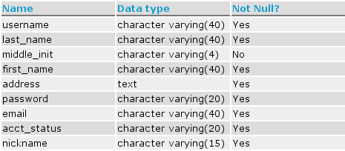
Table 1 USERS Data Dictionary

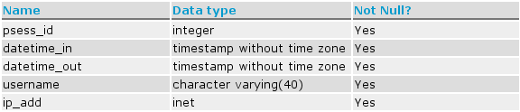
Table 2 PSESSION Data Dictionary

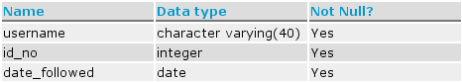
Table 3 PAS Data Dictionary

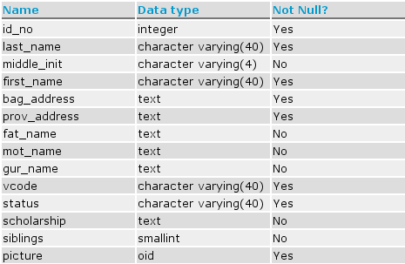
Table 4 STUDENTS Data Dictionary

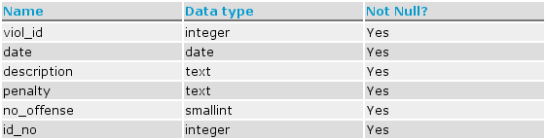
Table 5 VIOLATIONS Data Dictionary

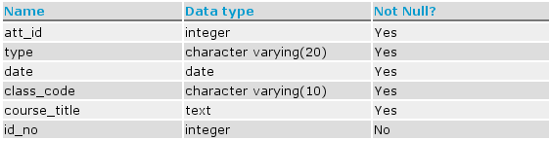
Table 6 ATTENDANCE Data Dictionary

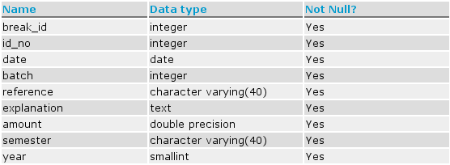
Table 7 BREAKDOWN Data Dictionary

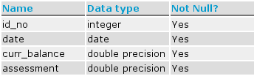
Table 8 BALANCE Data Dictionary

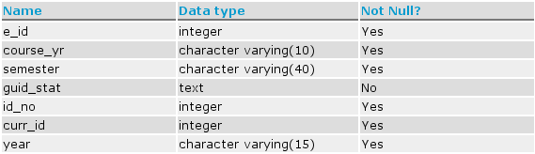
Table 9 ENROLMENT Data Dictionary

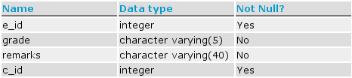
Table 10 ECL Data Dictionary

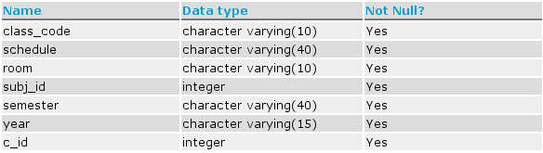
Table 11 CLASSES Data Dictionary

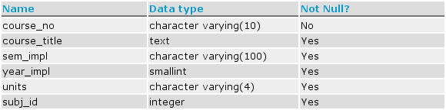
Table 12 SUBJECTS Data Dictionary

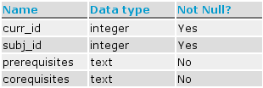
Table 13 CUS Data Dictionary

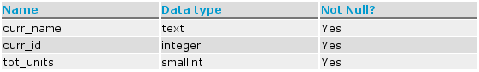
Table 14 CURRICULUMS Data Dictionary

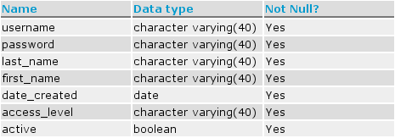
Table 15 STAFF Data Dictionary

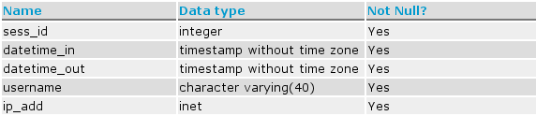
Table 16 SSESSIONS Data Dictionary

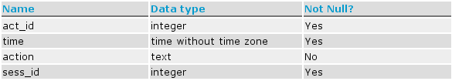
Table 17 ACTIONS Data Dictionary

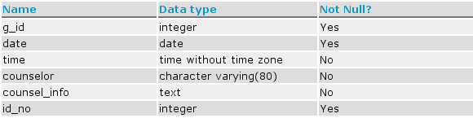
Table 18 GUIDANCE Data Dictionary

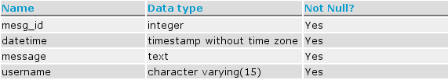
Table 19 MESSAGES Data Dictionary

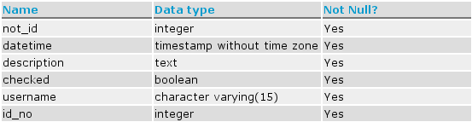
Table 20 NOTIFICATIONS Data Dictionary

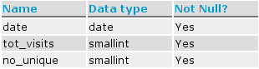
- Table 21 STATISTICS Data Dictionary

